UI/UX DESIGN SYSTEM

OnionGrade AI — UI/UX Design Specification
A premium, field-ready mobile experience for AI-assisted onion quality assessment
SIH 2026 • Problem Statement SIH26031 • Medium

Design North Star
“A procurement inspector should be able to create a lot, capture a standardized sample, understand the AI evidence, review the rule-based grade, and generate an auditable report without feeling like they are using a generic government ERP.”

1. Product Context
OnionGrade AI addresses SIH26031: quality and grading of onions can vary across procurement centres because assessment is visual, multi-parameter and time-sensitive. The research supplied for this project frames the product as an AI-assisted digital assaying workflow rather than a simple “photo → Grade A” classifier.
- Primary user: procurement inspector/operator.
- Core outcome: consistent, transparent and auditable lot-level assessment.
- MVP scope: visible external quality characteristics only; internal rot/density/moisture are explicitly outside normal smartphone-camera capability.
- Human-in-the-loop: low-confidence or ambiguous cases move to manual review.
- Offline-first: capture and assessment should continue when connectivity is unavailable, then sync later.

2. Reference Direction
The two uploaded reference images are treated as visual inspiration only. The first reference demonstrates a structured analytics dashboard; the second demonstrates premium dark AI/SaaS presentation. OnionGrade should borrow the hierarchy, cards, analytics, spacing and polish—not copy their layouts, branding or content.
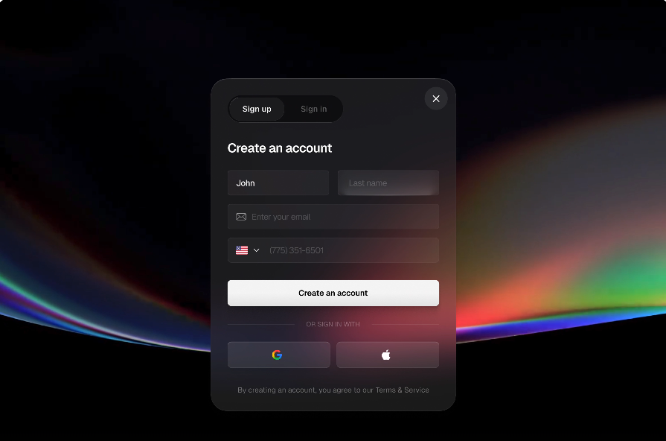
Reference image A supplied by the user — structured dashboard/card language.
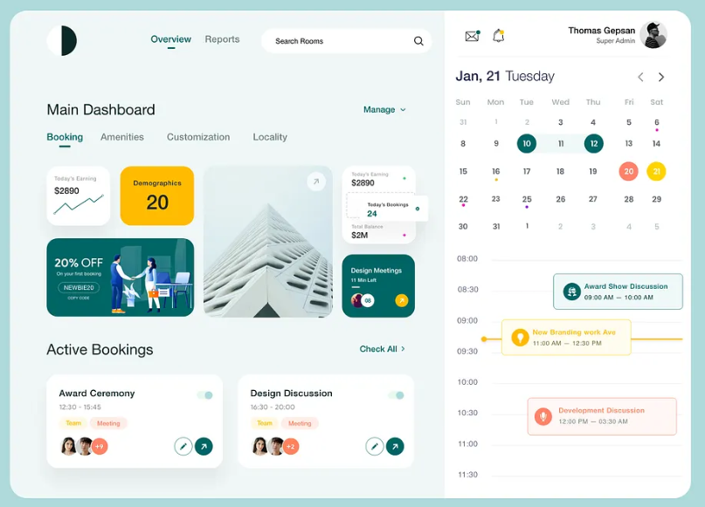
Reference image B supplied by the user — premium dark AI/SaaS language.

3. Visual Identity
Token | Specification | Use
Background | Deep navy/charcoal (#0B1020–#111827) | App shell and main surfaces
Primary | Violet/purple (#7C3AED family) | Primary CTA, active navigation, AI analysis
Secondary | Cyan/blue | Measurements, analytics, informational states
Success | Green | Accepted/Grade A / completed verification
Warning | Amber/yellow | Review, borderline, evidence needing attention
Danger | Red/coral | Rejected/defect/high-risk state
Surface | Raised dark cards + thin borders | Lot cards, defect cards, reports
Typography | Modern sans-serif; bold display + compact data labels | Strong hierarchy and scanability

4. UX Principles
- Capture first, analyze second: the UI should make standardized sampling impossible to miss.
- Evidence before verdict: every grade must expose the detected defects, measurements, rules and confidence.
- One primary action per screen: avoid clutter and reduce operator mistakes.
- Field-ready interaction: large touch targets, high contrast, readable numbers and short labels.
- Never imply certainty beyond the camera: visibly label the MVP as external-quality assessment.
- Offline continuity: show Sync Pending / Synced states without blocking the core workflow.
- Progressive disclosure: keep the default screen concise; allow inspectors to drill into individual onion/defect evidence.

5. Information Architecture
Login → Home → Create Lot → Guided Capture → AI Analysis → Review Result → Digital Report
- Home: Today’s lots, pending sync, quick Create Lot, recent assessments.
- Lots: searchable history with status, farmer, centre, quantity, grade and timestamp.
- Create Lot: procurement centre, farmer, lot ID, quantity and sample metadata.
- Capture: guided camera flow with distance/lighting/sample instructions and image-quality feedback.
- Analysis: processing state followed by onion detection, defect detection and measurements.
- Result: Grade A %, URS %, Other/Rejected %, average diameter, defect distribution, confidence and rule explanations.
- Evidence: original images, annotated defects, measurements, triggered rules and operator information.
- Report: digital report preview, report ID, export/share and sync status.
- Settings: operator profile, centre information, model/rules version, offline storage and sync.

6. Key Screen Specifications
Screen | UI/UX specification
Dashboard / Home | Hero card: Today’s inspected lots. KPI cards: lots assessed, Grade A average, pending sync, manual reviews. Primary CTA: Create New Lot. Recent lots list with status chips.
Create Lot | Minimal form. Required: centre, farmer, lot ID, quantity. Auto timestamp/operator ID. Optional notes. Validate before continuing.
Guided Capture | Full-screen camera. Overlay sample boundary/reference surface. Step indicator: Surface → Lighting → Distance → Multiple Views → Capture. Show image-quality warnings before AI analysis.
AI Analysis | Animated but restrained processing state. Show stages: image quality → onion detection → defect detection → size estimation → rules engine. Never show a fake confidence value while processing.
Lot Result | Large grade summary with Grade A / URS / Other. Below: defect distribution, average diameter, undersized %, sprouted %, rot/damage %. Primary action: View Evidence. Secondary: Generate Report.
Evidence Detail | Image with annotated onion/defect markers, measured diameter and defect label. Side/bottom panel shows applicable rule and AI confidence. Include Manual Review action.
Digital Report | Report ID, lot/farmer/centre, date/time, sample size, Grade A %, URS %, defect distribution, images, confidence, operator ID, final decision. Actions: Save PDF, Share, Sync.
Dispute / Review Mode | Timeline of original sample, detected defect, measurement, lot statistics, applicable rule, timestamp, assessor ID and AI confidence. Designed to answer “Why was this lot rejected?”

7. Result-State Visual Language
State | Color | Meaning | Required interaction
Grade A / Accepted | Green | Lot satisfies applicable Grade A criteria | View evidence / report
URS | Amber | Lot maps to URS under applicable rules | View rule explanation
Other / Rejected | Red | Criteria not satisfied | View evidence / manual review
Manual Review | Amber | AI confidence below threshold or ambiguity detected | Inspector reviews evidence
Sync Pending | Blue/Cyan | Saved locally, waiting for connectivity | Retry sync
Synced | Green/Cyan | Server copy confirmed | Open report

8. Dashboard / Analytics Direction
If the team adds the supporting procurement dashboard for the hackathon demo, it should reuse the same design tokens and show centre-level operational intelligence—not a generic admin panel.
- KPI cards: total lots, lots assessed, manual reviews, Grade A %, URS %, rejected %.
- Charts: grade distribution, defect distribution, centre-wise assessment volume, rejection patterns over time.
- Lot table: Lot ID, centre, farmer, quantity, result, confidence, assessor, timestamp, sync state.
- Filters: centre, date, grade, defect type, manual review and sync state.
- Do not add opaque “AI score” or candidate-style ranking.

9. Components
Component | Variants / behavior
Status Chip | Grade A, URS, Rejected, Manual Review, Sync Pending, Synced
KPI Card | Value + label + small trend/context
Lot Card | Lot ID + farmer + quantity + result + timestamp
Defect Card | Defect name + percentage/count + severity + evidence link
Evidence Viewer | Original image + annotations + measurement + rule
Progress Stepper | Create → Capture → Analyze → Review → Report
Primary Button | High-contrast violet; one per screen
Secondary Button | Ghost/outline; safe secondary actions
Chart Card | Minimal gridlines, clear legends and readable labels
Sync Indicator | Offline / Syncing / Synced / Failed
Bottom Sheet | Rule explanation, filters and detailed evidence

10. Responsive & Accessibility Rules
- Mobile-first; optimize for common Android phone widths.
- Touch targets at least ~44 px where practical.
- Do not rely on color alone; pair colors with labels/icons.
- Use large numerals for measurements and grade percentages.
- Support dark-first UI with sufficient text contrast.
- Use skeleton/loading states for network/model calls and explicit empty/error states.
- For slow devices or weak networks, avoid heavy animation and large image payloads.

11. Critical UX States
State | Expected UI
No lots yet | Friendly empty state + Create New Lot CTA
Camera permission denied | Explain why camera is required + retry/settings path
Poor lighting | Capture blocked with actionable lighting guidance
Occluded sample | Ask for rearrangement / another view
AI unavailable | Keep captured evidence, mark Pending Analysis, allow retry
Low confidence | Manual Review state; do not silently assign a definitive grade
Offline | Continue locally; show Offline banner and Pending Sync
Sync conflict/failure | Keep local record intact; show retry and last attempt
No report generated | Preserve assessment; retry report generation

12. Antigravity Build Brief
Use this as the UI/UX source of truth when generating the application. Build the visual system before individual screens, then reuse the same components across every flow.
Antigravity visual instruction
Create a premium dark, AI-native procurement inspection app. Use deep navy surfaces, restrained violet gradients, cyan analytics accents and semantic green/amber/red states. Use rounded cards, thin borders, clean Lucide-style icons, strong numerals and generous spacing. Do not generate a generic Bootstrap/ERP interface. Make the capture and result screens the visual centre of the product. Every AI result must be explainable through evidence and rules.

